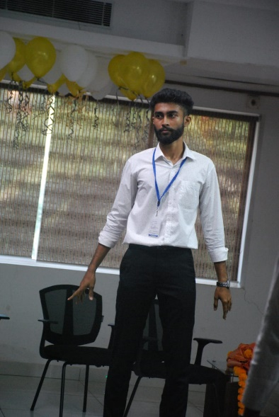

PAVAN SHETTIGAR

+918618351797

|| pavanshettigar29@gmail.com

Padmashree Nivasa Mijar, Daddi, Korettu, Mangalore

Karnataka, 574267

Linkedin:

https://www.linkedin.com/in/pavan-shettigar-1a439b272/

# SUMMARY

A dedicated team player and hardworking engineering student, I am passionate about Artificial Intelligence and have focused on AI-related courses and curriculum alongside various software development skills while keeping a close eye on emergent technologies. I am currently seeking a technical role that will enable me to enhance my professional and domain skills and leverage them for the overall benefit of the organization.

# EDUCATION

Bachelors of Engineering – Information Science 2021-2023

A.J Institute of Engineering & Technology. (VTU) CGPA: 7.8 (till 2nd year)

Senior Secondary (12th) 2020-2021

Alva’s Pre-University College, Mangalore. (PUC) Percentage: 92.50%

Secondary School (Class X) 2018-2019

Holy Family English Medium School. (State) Percentage:85.12%

# TECHNICAL SKILLS

Languages : C, C++, Java, Python, CSS, Javascript,Flutter.

Tools : Solid Edge.

Interface : HTML

# INTERNSHIP

**10 SECONDS | Trainee**

I have successfully completed my Intra-Inter Institutional Internship Training on ‘C Programming’ from 11.10.2023 to 15.10.2023

# PROJECT

**Gymnast**

Description: Contributed to the development of a virtual coaching platform designed to bridge the gap between aspiring athletes and experienced coaches. The platform offers user profiles, coach selection, virtual fitness challenges, a reward system, and nutrition tracking for meal planning

# COURSES & WORKSHOPS

* Participated in workshop on “Exploring the world of Generative AI using IBM WatsonX”
* Participated in Technical Talk on “Cyber Security and Ethical Hacking”
* I have recently completed the Energy Literacy Training course offered by Energy Swaraj, which has provided me with a deep understanding of energy concepts and the ability to make informed decisions regarding energy consumption and sustainability.